**Financial Market and Trading**

1. Financial instruments

**A. Money Market Instruments**

There are two types of financial markets.

1. **Capital markets**: It consist of stocks and bonds, allowing institutions to raise capital **for long-term** purposes, which is generally defined as more than one year. For example, a company may issue bonds in order to acquire another business, and will set the maturity date of those bonds for 10 years in the future.

2. **Money market**: funding over short time periods of one year or less. Instead of obtaining funding for operating expenses or capital investment as they would with the capital markets, the money markets are often used to fund immediate operating expenses or to provide working capital.

Short-term securities: maturity within one year or within the company's operating cycle.

no matter with trading: If you buy a stock at 10 and then sell it at 11, it is still not short-term security; the life of a stock is infinite.

* Treasury bills (short-term debt from the U.S. **government** with a maturity of one year or less)
* Certificate deposit (A savings certificate with a fixed maturity date and specified fixed interest rate from **banks**. A CD restricts access to the funds until the maturity date of the investment---forfeit liquidity for a higher return. e.g. GIC)
* Commercial paper (short-term debt instrument from a **corporation**, rarely range longer than 270 days)

Called Cash because of their **liquidity** (can convert to cash within one day or two) and **safety** (low risk and default)

**B. Government Fixed Income Securities**

* Federal Bond (e.g. Treasury bond is a marketable, fixed-interest U.S. government debt security with a maturity of more than 10 years)
* Provincial Bond (provincial government)

**C. Corporate Fixed Income Securities**

* Corporate bond
* International Bond
* Mortgage backed securities
* Preferred stock..

**D. Common Stocks**

There are thousands of publicly traded common stocks available in the market.

One classification could be based on

* Size (called also market capitalization) share price * #outstanding stocks
  + Large Cap stocks: $19 bln and up

(stable, lower growth potential because of the size)

* + Mid Cap stocks : between $2 bln and $10 bln
  + Small Cap stocks : less than $2bln
* Style
  + “Growth" company

e.g. Tech companies ..

* + “Value” company

e.g. McDonalds, Pepsi...

* + “Cyclical" company: Sensitive to business cycle

e.g. Auto manufacturing, home-building…

* Sector

Standard & Poor's breaks stocks into 10 sectors (consumer, health care, technology, financials, utilities..)

* + Health care and technology ► fastest growing sectors
  + Consumer, financials, and utilities ► more stable with moderate growth.
  + The other sectors tend to be cyclical expanding in good times and contracting during recessions

**E. Derivatives**

* Basic Positions
  + Call: Long(republish) vs Short(replenish)
  + Put: Long(replenish) vs Short(republish)
* Terms
  + Exercise (Strike) Price (pre-determined price)
  + Expiration Date (maturity)
  + Underlying Assets (stock, bond, currency...)

2. Classification of stock markets

**A. Primary Market (IPO)**

When a company publicly sells new stocks and bonds for **the first time**, it does so in the primary capital market. This market is also called the **new issues market**. In many cases, the new issue takes the form of an **initial public offering (IPO**). When investors purchase securities on the primary capital market, the company that offers the securities hires an **underwriting firm** to review it and create a prospectus outlining the price and other details of the securities to be issued.

All issues on the primary market are subject to strict regulation. Companies must file statements with the **Securities and Exchange Commission (SEC)** and other securities agencies and must wait until their filings are approved before they can go public.

Small investors are often unable to purchase securities at this point because the company and its investment bankers want to sell all of the available securities in a short period of time to meet the required volume, and they must focus on marketing the sale to **large investors** who can buy more securities at once. Marketing the sale to investors can often include **a road show** or dog and pony show, in which investment bankers and the company's leadership travel to meet with potential investors and convince them of the value of the security being issued.

**B. Secondary Markets**

The secondary market is where securities are traded after the company has sold its offering on the primary market. It is also referred to as the **stock market**.

Types

* **FIRST MARKET – Organized exchange :**
* Central location (NYSE, Toronto Stock Exchange (TSX))
* Auction

The secondary market has two categories: the auction and the dealer markets.

The **auction market** is home to the open outcry system where buyers and sellers congregate in one location and announce the prices at which they are willing to buy and sell their securities. The NYSE is one such example.

In **dealer markets**, though, people trade through electronic networks. Most small investors trade through dealer markets.

* Large firms (e.g. 1st Tier Stocks - Bleu chips (Old and elite firms)

This stocks are usually the **market leader** or come in the top three companies in its sector and are very well known and also have the market capitalization in billions.

They have a **long history of paying high dividends** to its investors

Note: NOT all stocks are bleu chips

* Listing requirements (Large capitalization, top quality in terms of stablilty...)

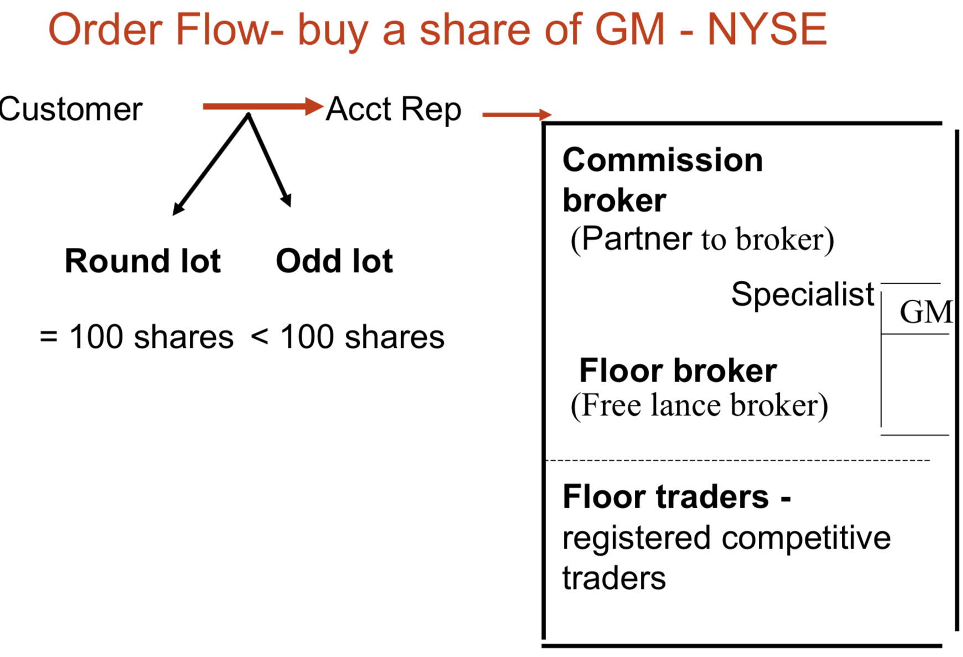

150 shares= 100 shares(round lot)

+50 shares(odd lot)

odd lot is slightly more expensive

[Duties of a specialist]

* 1 specialist per 1 stock/many stocks
* Maintain a book of all unexecuted orders and publish **Bid-Ask(spread of specialist)**

{Highest purchase price – Lowest selling price }

e.g. Bid: $30 Ask : $32 spread: $2

Cannot match-------if match, executed

*Investors who want to sell a security would get the bid price, which would be slightly lower than the actual price. If an investor wanted to buy a security, they would get charged the ask price, which is set slightly higher than the market price.*

* Act as ***market maker(Dealer)*** in a given stock
* Trade for their own accounts
* Typically large banks or financial institutions
* Ensure there's enough liquidity in the markets, meaning there's enough volume of trading so trades can be done seamlessly.

*Market makers help to keep the market functioning, meaning if you want to sell a bond, they are there to buy it. Similarly, if you want to buy a stock, they're there to have that stock available to sell to you.*

* Profiting on the bid-ask spread, which is the amount by which the ask price exceeds the bid price a market asset.

*Market makers are compensated for the risk of holding assets, because they may see a decline in the value of a security after it has been purchased from a seller and before it's sold to a buyer.*

* Act as ***broker***
* Intermediaries who have the authorization and expertise to buy securities on an investor's behalf.
* Earn commissions ---- NO risk

► Purpose is to maintain stability and continuity in the market...

* **2ND MARKET ---DEALER MARKET**

Dealers purchase assets for their own accounts, and sell them for a profit from their inventory

NASDAQ: doesn’t have a physical trading floor . (computer linked network)

**dealer's market**, *wherein market participants are not buying from and selling to one another directly but through a dealer, who, in the case of the Nasdaq, is a market maker*

Trade

* Second tier stocks (lower quality stocks that are not accepted by organized exchange)

Note: Top tier can be traded in both markets

* Emerging stocks (young firm with high potential but high risk)
* Penny Stocks (speculative but not solid)

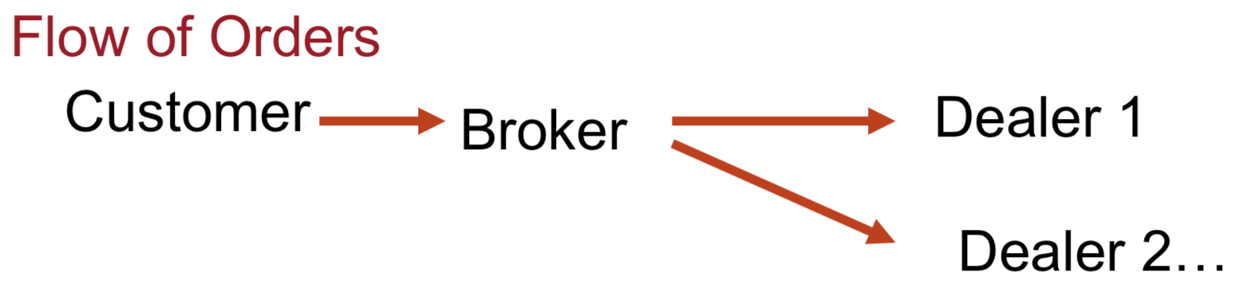

Find prices you like (negotiated markets)

Differences with Organized

* No central location
* Negotiated market
* Dealer’s market(no specialist)

*A market maker creates a market for a security, whereas a specialist merely facilitates it.*

* Can have more than 1 dealer per 1 stock

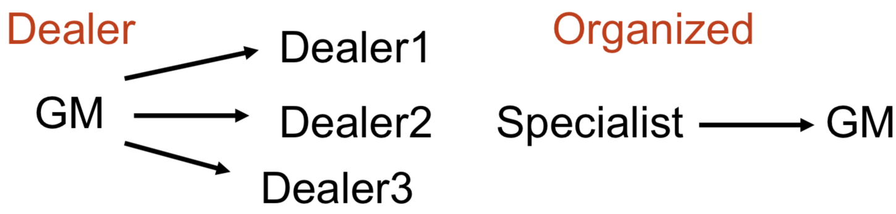

[Costs of Trading]

**Broker commission plus Bid-Ask spread**

* Commission: fee paid to broker for making the transaction

– Full service broker

Execution+ Additional services such as advice, research..etc

– Discount broker

* Spread: cost of trading with dealer

Bid: price dealer will buy from you

Ask: price dealer will sell to you

Spread: ask – bid

Investors buy at the ask price, and sell at the bid price

Dealers buy at the bid price and sell at the ask price

<Example>

Buy and sell 100 shares of XYZ firm

XYZ: [bid=$49.75 ask=$50] commission = $15

As an investor:

► Buy: $50*100+15=5015

► Sell: $49.75*100-15=4960

► Trading cost: 5015-4960=55

=0.25*100+2*15 two commision

[Pricing terminology]

* Tick: unit of trading
  + 1/8 of a dollar prior to 2001 in US
  + 0.01(decimal) since then
* Closing prices: last prices prior to closing of the exchange
* Opening prices: first prices at opening of the day (because of overnight trading)
* **3rd MARKET**

Trade listed stocks(first market) on NASDAQ(2nd market)

Ex : ATT

* **4th market**

Trade directly without brokers(no commission fees!)

Ex: hedge fund, big banks

Ex: Instinet

3. Stock Market Indexes

*Measure the* ***return of a basket of securities***

* + Measure general performance of the economy (Indicator in advance)
  + Bench mark for portfolio managers

Comparing performance of managers

* + Assess the direction of the market (for speculation)
  + Used to estimate beta, σ...etc (modeling)
  + Base of derivatives

**[Constructing an Index]**

* **Price weighted Average**

Ex ***Dow Jones Industrial Average***

Price weighted average of 30 blue chip sks ...out of more than 3000 stocks

DJIA = ∑ P/ D

D is adjusted for stock split, stock dividend

►Sensitive to higher price stock

* **Market Value index**

TSX, SP 500, NYSE Index, NASDAQ

Style Indexes such as small cap indexes RUSSELL 2000 , WILSHIRE 1750 ...etc

Ex SP 500 = ∑ P Q /(Base)

Q: quantity of shares

►Sensitive to higher value stock

4. Types of Orders

* **Market order** : buy/sell at the best current price
  + Market buy : buy at the lowest ask price
  + Market Sell : Sell at the highest bid price
* **Limit orders** (set condition)
  + limit buy : order to buy at a specified price or better (P* or lower)
  + limit sell : order to sell at a specified price or better (P* or higher)

<Example>

Suppose that the highest **limit-buy** order for a stock is $30 while the lowest **limit-sell** order is at $32. [ 30 – 32 ]

When a market buy order comes in, it is matched to the best limit-sell at $32

A market sell order would be matched to the best limit-buy at $30

As market buys and sells come to the floor randomly, the stock price would fluctuate between $30 and $32

* **Stop orders** (special orders): Order that specifies a given price at which point it becomes a market order
  + Stop Loss : order to sell if stock price hits a specified price P* (or lower)
  + Stop buy : order to buy if stock price hits a specified price P* (or higher)

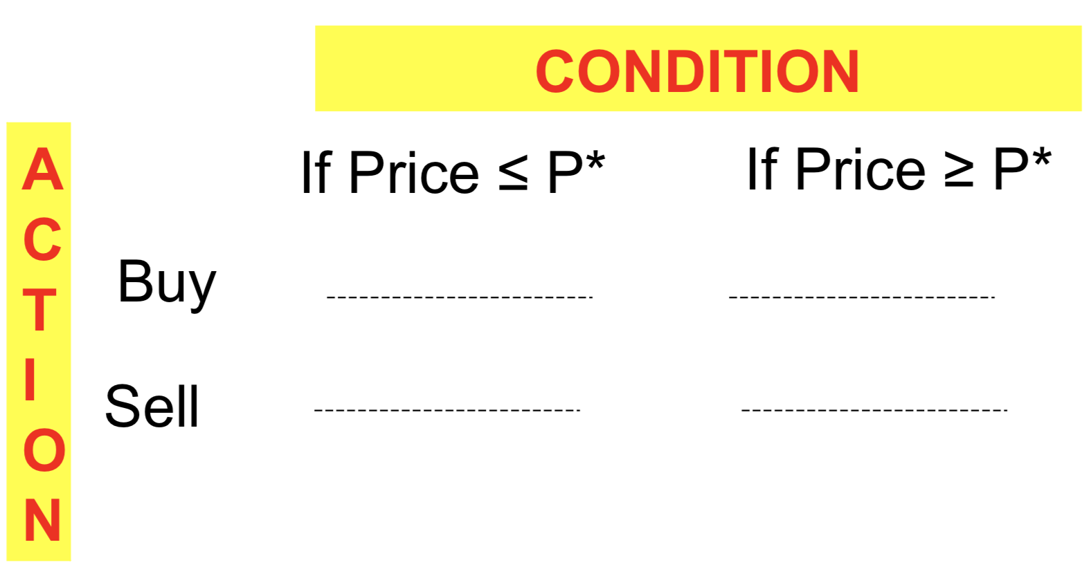

stop buy

limit sell

stop loss

limit buy

<Example>

* If you own stock ABC, which currently trades at $20, and you place a stop order to sell (stop loss) it at $15.

Your order will only be filled once stock ABC hits $15

* You bought stock ABC at $10 per share and now the stock is trading at $20 per share. You place a stop order to sell (stop loss) it at $15

This will guarantee profits of **approximately** $5 per share, depending on how quickly the market order can be filled.

* If you want to buy stock ABC, which is trading at $12, you can set a limit buy for $10..

This guarantees that you will pay no more than $10 to buy this stock

* You own stock ABC and it is trading at $12, you could place a limit sell at $15

This guarantees that the stock will be sold at $15 or more

4. Buy on Margin

* Buy (long) securities with borrowed money..

Why? Bullish (Stock price will go up)

* Investor borrows part of the purchase from the broker at a at a rate called *margin interest rate*
* Equity investment could be cash or securities
* Securities bought on margin are left with brokers as collateral-“Acct in Street Form”
* Regulators set limits on buying on margin .i.e limit the margin to which stock purchases can be financed via margin (=Equity/Securities)
* Initial Margin = 50% (borrow 50% or lower)
* Maintenance Margin = 30%

<Example>

P0 = $100, buy 100 shares financed with 40% of the value of securities at rB = 10%

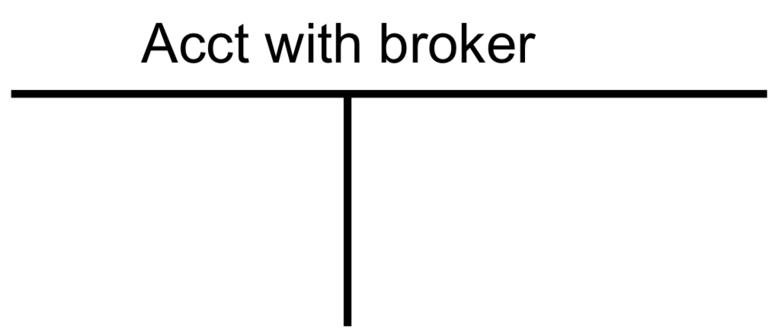

Sk 10,000

Loan 4,000

Equity 6,000

Initial Margin=6/10=60%>50%

Maintenance Margin=30%

End of year ► If stock price = $120

With margin

Income = (120-100)*100-4000*10%=1600

return=profit/equity investment

Return = 1600/6000=26%

Without margin

Income = (120-100)*100=2000

Return = 2000/10000=20%

LEVERAGE

End of year ► if stock price = $50

Brokers do daily *marked to market* to find out *margin call (check if reached maintenance margin at 30%)*



Sk 5,000

Loan 4,000

Equity 1,000

Margin=1000/5000=20%<30%

Receive margin call to add cash (Must maintain at least 30% of $5000=$1500) and/or sell securities 0.3=[50(100-x)-(4000-50x)] / [50(100-x)] 🡪 x=33.33

How far could the stock price fall before you receive a margin call?

0.3=Equity/Security=(TotalAsset-Debt)/Security=(P*100-4000)/(P*100)

🡪 P=$57.14 benchmark

6. Short Sale

*short sell: sell sth you don’t own*

*short: sell sth you own*

* Investors borrows the stocks and sell them..

Why? Bearish

* Proceeds from sales must be kept with the broker as collateral

+Provide collateral to cover any loss

* Cover (offset) the short position, i.e. repurchase the share and give it back to the original owner (and pay any dividend, if any ~ opportunity cost)
* Margin requirements (same as margin)
* Initial Margin
* Maintenance Margin

<Example>

P0 = $100, short sell 1000 shares, provide collateral = $50K of T-bills

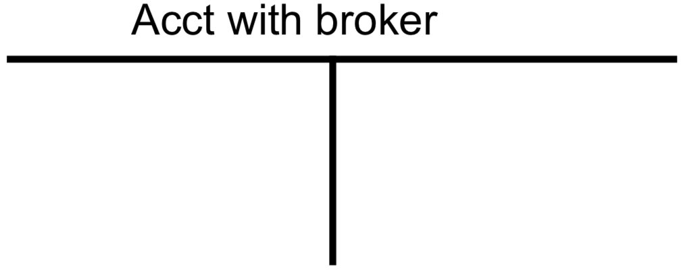

Equity 50,000

liability

asset

cash 100,000

T-bill 50,000

shortsale=100,000

Initial margin=50%

End of year ► if stock price = 80, dividend paid out = $1/share

Profit = (100-80)*1000-1*1000=19,000

Return =19000/50000=38%

End of year ► if stock price = 120

Loss = (100-120)*1000-1*1000=-21,000

Return =-21000/50000=-42%

LEVERAGE

Q: Hedge(reduce risk) against price increase using order?

Stop buy

Q: How far could the stock price increase before you receive a margin call?

0.3=[150000-1000x]/1000x 🡪 x=115.38